Optimizing the State Home Care Program and Eliminating Waitlists
Policy Memo Prepared by Peter Tiernan for Members of Dignity Alliance Massachusetts
Topic Areas: Home and Community Based Services, Public Finance and Administration, Medicaid HCBS Waivers, Elder Care Services Portfolio
Version 1.1, March 2026

- THE HEALEY-DRISCOLL ADMINISTRATION SHOULD TAKE STEPS TO GENERATE AT LEAST $50M PER YEAR IN NEW FEDERAL FINANCIAL PARTICIPATION REVENUE BY CONVERTING THE EXECUTIVE OFFICE OF AGING & INDEPENDENCE ENHANCED COMMUNITY OPTIONS PROGRAM (“ECOP”) INTO MEDICAID-REIMBURSABLE ACTIVITY. THESE NEW REVENUES WILL ENABLE THE ELIMINATION OF RECENT AND CONCERNING HOME CARE WAITLISTS WHILE SUBSTANTIALLY REDUCING THE NET COST OF THE STATE HOME CARE PROGRAM TO THE GENERAL FUND.
- BY CONVERTING THE LONG-STANDING ECOP PROGRAM TO A 1915(C) WAIVER PROGRAM, All INCOME-ELIGIBLE ELDERS (approximately <$35,000 per year; 90% of current program census) WILL HAVE ACCESS TO ENHANCED SERVICE PLANS.
- AFTER FACTORING FOR FULLY SUPPORTING WAITLISTED CONSUMERS (950 individuals as of 9/26), THE NET COST TO THE GENERAL FUND WILL STILL BE 35% LESS THAN THE COST OF CURRENT SERVICES. ANNUALIZED REDUCED PROGRAM COSTS IS ESTIMATED AT $38.5M.

Overview
Background: The Executive Office of Aging & Independence (“AGE”) operates the State Home Care Program, which primarily serves low-income older adults with needs for long-term services and supports. An important sub-program, the Enhanced Community Options Program (“ECOP”) offers a higher level of services than the Basic Program. ECOP is reserved for individuals who clinically qualify for a nursing home placement. Approximately 75% of ECOP program participants have household income <$30,000 per year; and 85% of participants live alone.

Problem: Since 3/1/25, in response to budget constraints AGE has been managing down census by sharply limiting access to ECOP. In January 2025, the ECOP program supported 9,283 active consumers; for January 2026 AGE has capped the program at 5,374 active consumers. This 42% caseload reduction is highly concerning and should be more widely known by the general public. A recent public records request suggested that as of 9/26/25, there were 950 low-income elders who were clinically eligible but waitlisted for enrollment to the ECOP program. To be clear, a year ago these 950 consumers would have been enrolled in the ECOP program. This waitlist has been implemented with very little, some would say insufficient, public dialogue.

Solution: AGE can and should act now to convert approximately 90% of ECOP-eligible program census (both active and waitlisted) into a special Medicaid-funded waiver program and thereby generate matching federal funds as new program revenue. This can be accomplished by MassHealth leveraging two policy tools that CMS makes available to state Medicaid programs, one of which is relatively new and not yet deployed in Massachusetts.
Annualizing September 2025 ECOP program experience, a prudent transformation should generate $50-$55M per year in new FFP revenue. After assuming that the ECOP waitlist is eliminated and all eligible consumers have access to enhanced service plans, the net cost to the General Fund would still be approximately $38M less than the current program configuration. A portion of these additional savings should be committed towards eliminating the waitlist in the State Home Care Basic Program. The author also strongly recommends committing a portion of new funds towards supporting Public Guardianship services for individuals who are Nursing Home Residents or at risk of nursing home placement.

Defining Current State: AGE Home Care Program
Enabled by M.G.L. c. 19A, § 4, the AGE State Home Care Program provides important in-home services and supports primarily for low-income seniors with long-term care needs. The State Home Care Program is actually an array of several sub-programs that create a continuum of enrollment options based on clinical criteria (level of care/clinical acuity/care complexity) and financial criteria (household income, and in some instances available assets/resources). There are numerous options for how the AGE program options could be presented to an interested audience. For purposes of this policy brief, analysis is going to be limited to the sub-programs that are funded by appropriations ELD 9110-0600, -1630, and -1633. This brief is not concerned with Older Americans Act-funded services.
Furthermore, the focus of this policy brief is limited to Home Care Program participants who have clinical care needs that would qualify for a MassHealth-funded nursing home placement, otherwise referred to as “Nursing Facility Level of Care Equivalent” (“NF-LOC”).
Figure One isolates on the routine AGE program census that is being analyzed for potential to convert to a new 1915 (c) waiver program. The snapshot is from September 2025. Note that in addition to the 6,083 consumers who actively received services in the ECOP program, it is estimated that 836 individuals clinically qualified but were waitlisted while being supported by a less intensive service program in the “Basic” program.

Figure 1
Current State Overview of Program Census

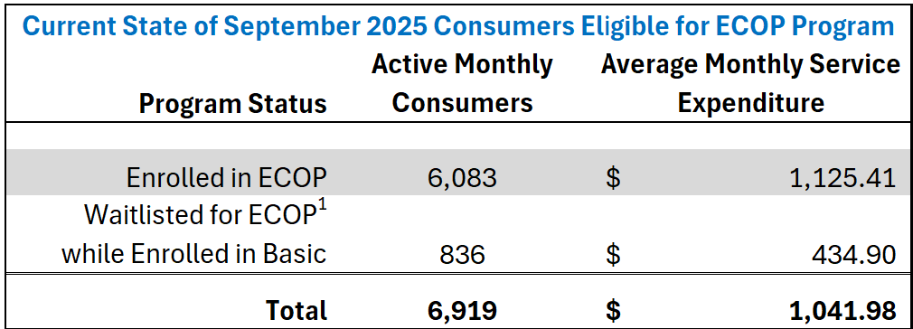
1: For detail on information source and methodology for converting from enrollment/headcount to active monthly consumer/billable unit, please see the notes in the accompanying excel workbook, worksheet tab "Current State ECOP Sept. 2025".

Converting ECOP to Medicaid-Reimbursable Activity: A New “Limited Frail Elder Waiver” Program Option
There are two policy options made available by CMS to states that can be applied to the ECOP program for the purpose of efficiently converting existing AGE service commitments into Medicaid-reimbursable activity. MassHealth has not deployed either of the policy options in the administration of any of their current 1915(c) waiver programs, including the Frail Elder Waiver. Furthermore, one of the policy options is relatively new and not yet in wide use by other states.
The concept is to establish a new 1915(c) waiver program that is placed on a continuum between the current ECOP Program and the well-known Frail Elder Waiver (“FEW”) program. This new 1915(c) program will provide a more limited service offering to participants in comparison to the FEW. The key distinction is the new program, tentatively titled “Limited Frail Elder Waiver”, will have a less restrictive financial eligibility criterion.

Figure 2

Demonstrating Census Distribution of ECOP-Eligible Consumers Under Current State of AGE Programs
Compared to Optimized Scenario of Offering a New 1915(c) “Limited Frail Elder Waiver” Program

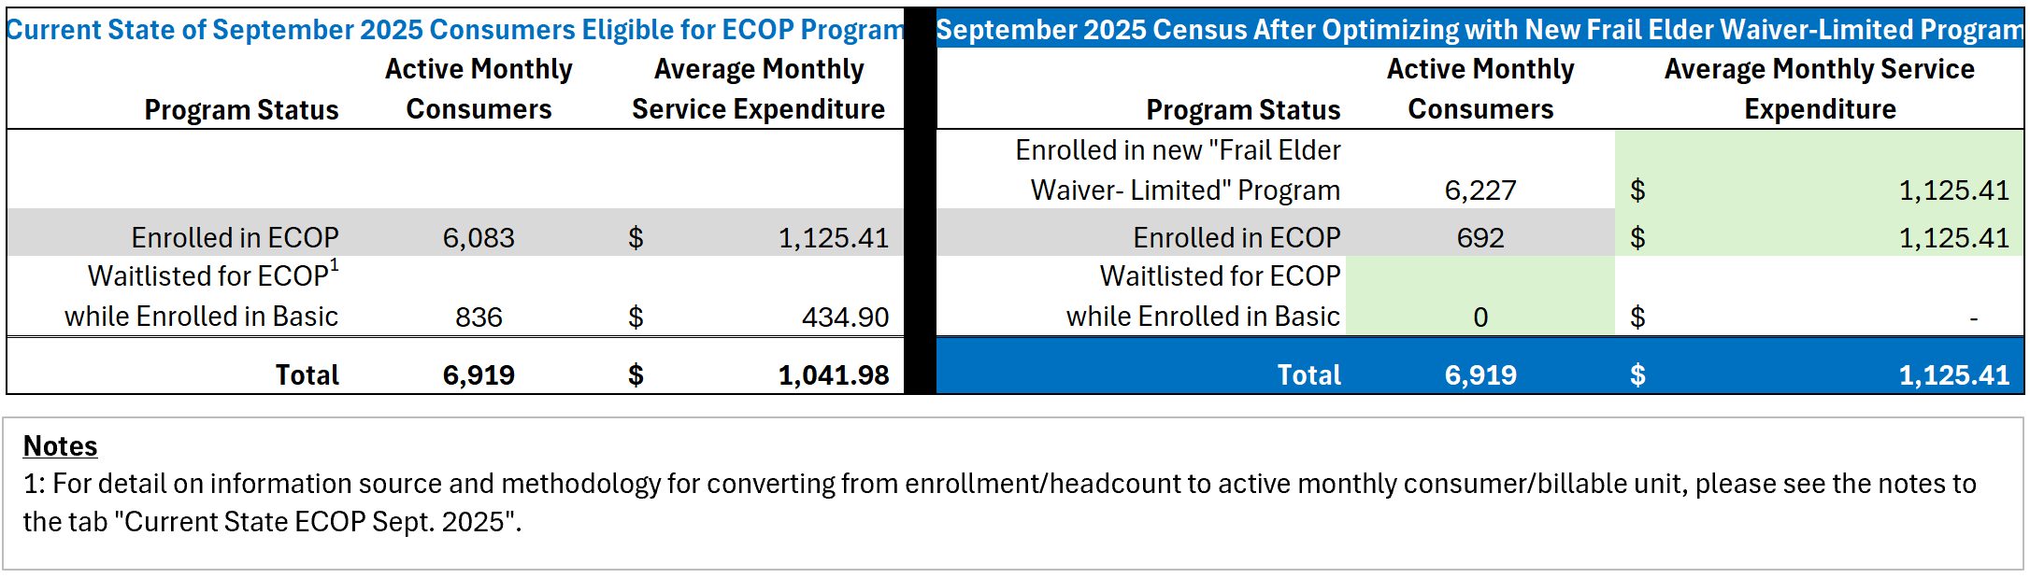

Key Design Elements to the Proposed “Limited Frail Elder Waiver” Program
In order to attain the redistribution of consumer census suggested by Figure 2, the key design elements to the Limited Frail Elder Waiver Program will need to include the following considerations:
- Same clinical eligibility as the Frail Elder Waiver.
- Same income eligibility standard as the Frail Elder Waiver.
- Less restrictive resource requirement, designed to facilitate enrollment by current ECOP membership. The ability to implement a resource eligibility criterion that differs from nursing home eligibility was recently clarified by CMS State Medicaid Director Letter (SMD) #21-004. As such, there are few instances of other states making use of this important clarification (see below discussion “Targeted Resource Disregard for Applicants to Limited Frail Elder Waiver Program”). An open design question is whether there should be any asset/resource requirement whatsoever; or to adopt a high ceiling (for example $130,000) for the purpose of ensuring all Limited Frail Elder Waiver participants are subject to look-back eligibility determination procedures. The author’s current preference is to not utilize an asset test as it is thought that the overhead involved in administering such eligibility criteria is not cost-effective; but this is a matter that merits additional deliberation. This presentation assumes MassHealth will proceed with a ceiling of $130,000.
- Unlike the Frail Elder Waiver (and any other Massachusetts 1915(c) Waiver), to implement an individual cost limit on combined waiver and state plan services. The emphasis on including state plan services is to proactively address anticipated MassHealth concerns about creating an exposure to expanding AFC, PCA, or ADH services. The individual service cap applies to all MassHealth provided services (not just HCBS waiver services), and the cap would be set in a manner consistent with current ECOP cost obligations. The recommended cap is $1,275 per month (see below discussion “Leveraging 1915(c) Option for States to Adopt an Individual Cost Limit Inclusive of State Plan Service Costs”).
  - For Limited Frail Elder Waiver participants who have service needs that exceed the service cap, the consumer can pursue eligibility in the traditional Frail Elder Waiver which does not have an individual service limit. Keep in mind that such consumers will need to satisfy the stricter asset/resource requirements of the traditional Frail Elder Waiver in order to access the more generous service plan.
- Unlike the Frail Elder Waiver, to implement a point-in-time enrollment limitation on the number of active monthly participants. This monthly enrollment limitation will essentially correspond with the number of ECOP-eligible participants. This feature will guard against likely “woodwork effect” concerns that will be initially raised by MassHealth management.
- Year One of the waiver to include target population criteria that reserves enrollment capacity to first enroll individuals in the state home care program who are participating in or waitlisted for the ECOP program.

Fiscal Impact Overview
The reader who is interested in comprehensively reviewing the financial proposition is strongly encouraged to examine the accompanying excel workbook, “Optimizing ECOP Program for Full Enrollment and FFP Maximization”. Figure 3 offers summary analysis that replicates the Commonwealth September 2025 service experience with 6,919 active ECOP-eligible consumers (836 of whom were waitlisted) and simulates their service experience assuming the Limited Frail Elder Waiver program were in place. In annualized terms, analysis suggests that after eliminating the waitlist and factoring for the new FFP revenue that will be generated by this program, the net cost to the general fund for serving these consumers would have been $38.5m less than the current program operational footprint.

Figure 3

Comparing Current State Fiscal Operation of ECOP-Eligible Consumers to
Simulated Fiscal Operation with new “Limited Frail Elder Waiver” Offering

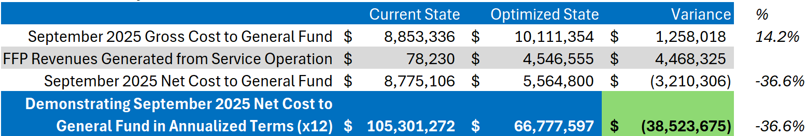
For the benefit of the audience of elder care service advocates, the author emphasizes that the simulated $38.5m net cost reduction is after relieving the ECOP Waitlist and maximizing enrollment in the new Waiver program. In the below section “Additional Considerations”, some re-investment considerations are highlighted. Traditionally, on an initiative such as this a broad coalition of elder service advocates would collaborate to promote the majority of the net-cost savings re-invested into the Elder Services portfolio.

Applying a Targeted Resource Disregard for Applicants to a Limited Frail Elder Waiver Program

CMS State Medicaid Director Letter (SMD #21-004, December 7, 2021) provides states with flexibility under §1902(r)(2) of the Social Security Act to apply less restrictive financial methodologies—including income and resource disregards—specifically for individuals seeking Home and Community-Based Services (HCBS) under §1915(c), §1915(i), §1915(k), or §1115 authorities. This flexibility allows states to tailor financial eligibility rules for HCBS populations without altering institutional eligibility standards.
The concept for Massachusetts is to consider the emergence of SMD #21-004, and to give fresh consideration of the Commonwealth’s long-standing safety net commitments that it has made via the AGE ECOP program. While some states may rely on SMD #21-004 to launch new initiatives, it is also incumbent on state policy makers to consider how to apply new HCBS policy tools enabled by CMS towards existing state programs. It is only appropriate for Massachusetts to be able to attain FFP revenue in instances where CMS has extended its Medicaid-funded HCBS offerings in areas where the Commonwealth has been an established practice leader signaling where CMS needs to improve and innovate on HCBS policy.
Many years ago Massachusetts recognized that the nursing home asset-test eligibility criteria was burdensome and a barrier to low-income elders who required prompt access to a meaningful level of HCBS supports. As such, the ECOP program was initially launched as a proving ground for the Frail Elder Waiver and related expansion initiatives….and it now serves as a bridge to enable enhanced service plans while low-income elders are proceeding through the Frail Elder Waiver eligibility determination process. Now that CMS has issued the common-sense clarification that decoupled HCBS financial eligibility criteria from SNF financial eligibility criteria, it is prudent for Massachusetts to restructure the ECOP program accordingly.
Alternatively stated, if Massachusetts was today establishing an ECOP program, it would most likely take advantage of SMD #21-004 and it would bear resemblance to this proposed Limited Frail Elder Waiver program.

Suggested Implementation Steps
Concurrent with the filing of a new 1915(c) Waiver [Limited Frail Elder Waiver], to also file a State Plan Amendment (SPA):
Submit a SPA under §1902(r)(2) specifying the disregard: For applicants under the Limited Frail Elder Waiver, resources up to $130,000 are disregarded for financial eligibility purposes.
Sample SPA language: Massachusetts elects to apply a less restrictive resource methodology under §1902(r)(2) for individuals applying for the 1915(c) Limited Frail Elder Waiver. Resources up to $130,000 will be disregarded when determining financial eligibility for this waiver population. This disregard does not apply to institutional eligibility groups or other Medicaid categories.

Governance Notes
- Social Security Act §1902(r)(2): Permits states to use less restrictive methodologies for certain eligibility groups.
- CMS SMD #21-004: Authorizes targeted disregards for HCBS populations.
- 42 CFR §435.601: Governs application of financial methodologies.
- It is acknowledged that the necessary language specifying the asset disregard may be accomplished within just the 1915(c) waiver application, and that no additional SPA amendment is needed. This “belt and suspenders” approach of including a SPA amendment is offered to help underline the relative simplicity of the related CMS transaction.

Leveraging 1915(c) Option for States to Adopt an Individual Cost Limit Inclusive of State Plan Service Costs
The 1915(c) waiver is a powerful policy tool extended to state Medicaid programs that allows states to provide long-term services and supports to individuals outside of institutional settings. The 1915 (c) authority lets states “waive” certain Medicaid rules so they can offer services that help people remain in their homes or a “home-like” setting instead of being placed in an institutional setting. 1915(c) authority accords states a remarkable amount of discretion in support of designing impactful, cost-effective, and highly customized HCBS program and service offerings. CMS has done an excellent job publishing technical assistance to support and accommodate each state’s policy preferences. One such tool not yet explored by Massachusetts but essential for this initiative is the adoption of an “Individual Cost Limit” that applies to both waiver services and other state plan services. For this ECOP optimization initiative, the specific option is the “Cost Limit Lower Than Institutional Services”.
From pg. 79 of CMS “Technical Guide for 1915(c) Waivers”:
Cost Limit Lower Than Institutional Services. Finally, a state may elect to impose an individual cost limit that is lower than the cost of the institutional services for the level of care that the person requires. The selection of this limit generally is only appropriate in the case of waivers that target individuals who can be expected to have available services and supports from other sources (e.g., family caregivers or other public programs) that, in combination with waiver services, will be sufficient to assure their health and welfare pursuant to 42 CFR § 441.302(a). When a state elects this choice, it must specify the basis of the limit that it imposes (i.e., the information analyzed and the rationale to support the assertion that the limit selected ensures that individuals who enter the waiver will have sufficient services and supports to assure their health and welfare). This evidence may be based on:
o An analysis of service utilization in a waiver that serves a similar target group;
o An analysis of service utilization in a state program that serves a similar target group;
o The experience of a waiver that serves a similar target group in another state; and/ or
o An assessment of the service needs of individuals in the target group.
To begin considering how to develop an appropriate cost limit consistent with the current Massachusetts ECOP program, ASAPs currently receive a monthly “Direct Services” payment from AGE which they utilize to purchase services on behalf of ECOP consumers. Each ASAP essentially manages a de facto capitated payment across its local risk pool of ECOP consumers. The relevant monthly service rates are established and biennially revised by 101 CMR 417.00. The current monthly capitated payment AGE issues to the ASAPs is $1,025.12 per month; a June 2025 management report indicated that the ASAP network was spending approximately $1,125.41 per month on direct care services.
Numerous factors result in the dynamic of services delivered being less than the amount of services authorized by a service plan. It is asserted that a service plan limit of $1,240.00 will support the ongoing per member per month spending of $1,125.41. It is stressed that the development of a service plan limit should be extended to include both waiver services and state plan services.
Assuming Massachusetts adopts this concept of a Limited Frail Elder Waiver, it will be important for AGE/MassHealth to emphasize that for this waiver there is a definitive and enforced individual cost limit that is less than a nursing facility cost equivalent. For consumers with service needs that cannot be adequately addressed by this waiver, the Frail Elder Waiver continues to be an option. The Frail Elder Waiver does not utilize an individual cost limit. The trade off is that in order for the consumer to access the Frail Elder Waiver, they will have to meet more rigorous financial eligibility criteria.

Suggested Implementation Steps
Using the existing 1915(c) Frail Elder Waiver as template, with the major difference of activating an “Individual Cost Limit” in Appendix B-2. In contrast with the Frail Elder Waiver, change the pre-populated selection from “No Cost Limit” to “Cost Limit Lower Than Institutional Cost”.
Furthermore, for the required justification statement along a suggested draft is: “The basis of the individual cost limit is informed by both the long-term experience of administering the Frail Elder Waiver in combination with a non-Medicaid state program offering enhanced care supports for low-income elders with qualifying care needs. This option is elected with understanding that the Frail Elder Waiver will continue to be available to individuals who have service needs that exceed the individuals cost limit established by this waiver.”
Furthermore, to elect a dollar amount of $1,240.00 for Waiver Year One.
Furthermore, to elect an “adjusted each year” option with specification that for the remaining outyears of the Waiver, an annual inflationary adjustment will be applied to the Individual Cost Limit in a manner consistent with the corresponding year-to-year change in the “Home Health Agency Market Basket” index posted by the United States Department of Health and Human Services, Centers for Medicare and Medicaid Services.
Using the existing 1915(c) Frail Elder Waiver as template, with the major difference of activating a “Limitation on the Number of Participants Served at Any Point in Time” in Appendix B-3(b). In contrast with the Frail Elder Waiver, this Limited Frail Elder Waiver should have an enforced number of participants served at any point during a Waiver Year. Deference is given to AGE for setting an appropriate limit, but “Waiver Year One” should be established at a level sufficient to facilitate the conversion of 90% of active ECOP consumers + 90% of Basic consumers who are on the ECOP waitlist. If designing based on September 2025 census, the appropriate limitation would be approximately 6,230 participants.

Addressing Anticipated Objections

Regarding Risk to DSHP Revenue
This initiative estimates that the current General Fund commitment to the ECOP program can be maximized in a manner to generate at least $53M per year in new Federal Financial Participation Revenue. It is anticipated that MassHealth financial analysts will be overly quick to claim that the existing 1115 Waiver Demonstration’s Designated State Health Plan (DSHP) is currently reliant on the State Home Care Program to serve as a source of “in-kind” contributions that are generating FFP revenue which, in turn, is serving as foundation to the DSHP financing plan.
It is stressed that the AGE State Home Care program will be able to convert the ECOP program to a 1915(c) “Limited Frail Elder Waiver” while also meeting its expected in-kind contributions to the active DSHP initiatives. Figure 4 demonstrates the DSHP financial plan, with detail on the “non-federal share” match expected from the state home care program. In CY2026, the AGE state home care program is expected to contribute $63.4M; and CY2027 the expected match is $31.7M. For both of these years, the state home care program can easily meet the contribution expectation from just the Home Care Basic Program and not involve ECOP operations.
Figure 4
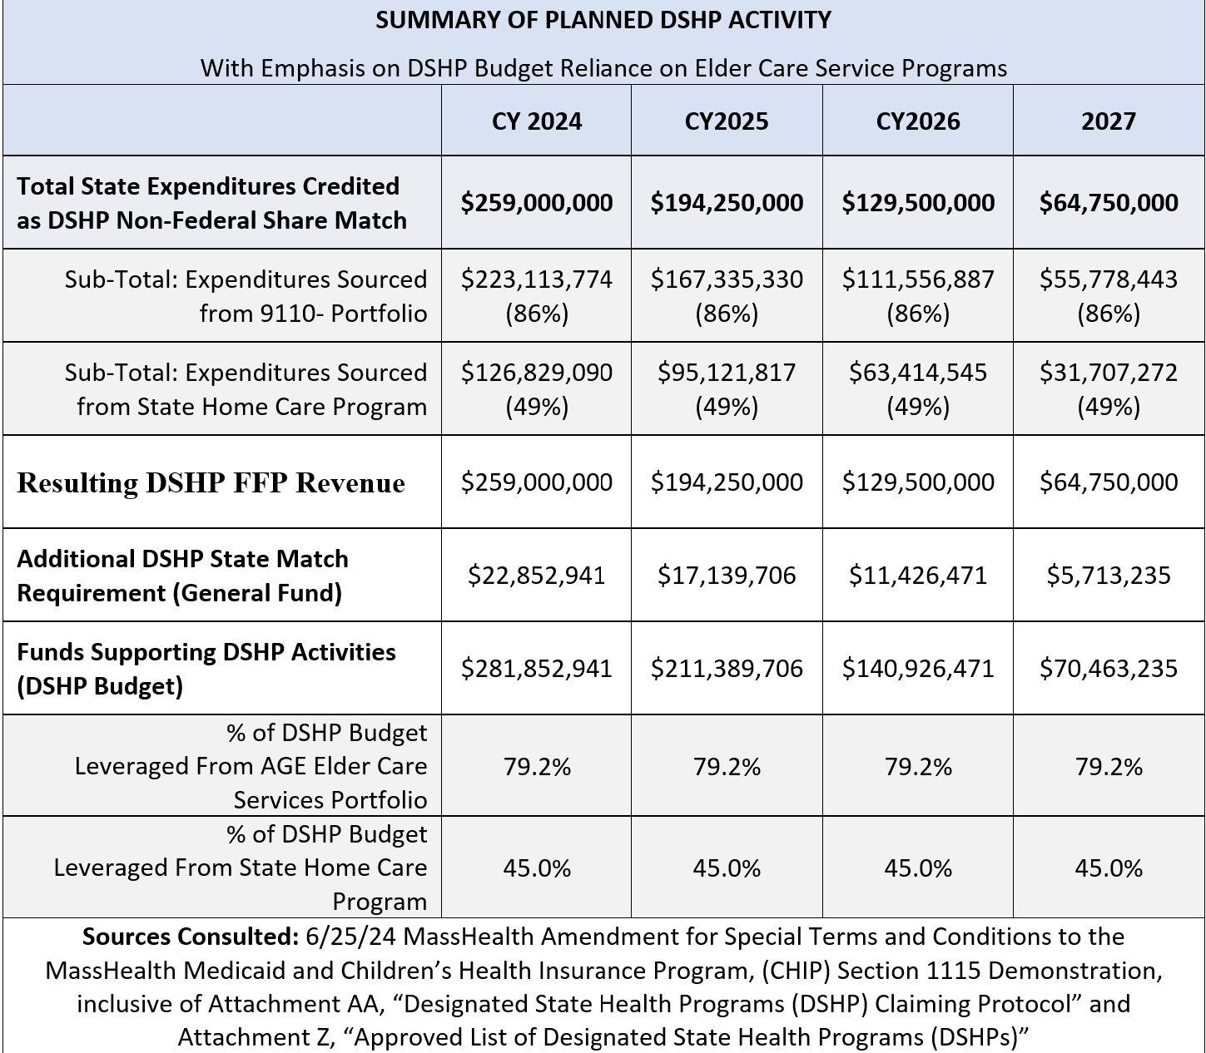

Regarding Woodwork Effect
It is stressed that this initiative is developed from the perspective of first understanding the existing General Fund commitments of the AGE State Home Care program, the low-income consumers who are certified NF-LOC and actively benefiting from the program, and the consumers who are likely NF-LOC currently being waitlisted for the program. The resulting program design of a “Limited Frail Elder Waiver” is carefully considered to target serving these individuals while also installing sufficient guardrails that protect against the common MassHealth scarecrow otherwise known as “woodwork effect”. The combination of an individual cost limit and a monthly limitation of the number of unduplicated participants expressly mitigates/eliminates traditional “woodwork effect” concerns that MassHealth tends to raise.

Implementation Considerations

Stabilizing ASAP Risk Pool
This process of converting the ECOP program to a 1915(c) Waiver Program will result in the AGE method for compensating ASAPs changing from a de facto monthly capitation payment to a cost-reimbursement method. Implementing the change is not complicated, as it mirrors the manner by which AGE reimburses ASAPs for the operation of the long-standing Frail Elder Waiver program. However there needs to be mindful awareness of the important elder care service delivery system that has become dependent on surplus funds that flow from ECOP capitation payments.
This proposal estimates that, as a result of this initiative, net program costs to the General Fund will be reduced by at least $38M per year. It is asserted that for the purpose of promoting stability to elder care services being routinely delivered by the ASAP network, that no less than $2.0M of the cost savings should be re-invested into the home care program. This re-investment initiative should be in the form of a broad-purpose formula grant that compensates ASAPs for demonstrated non-reimbursed costs incurred in the course of providing local services consistent with the mission of the AGE State Home Care Program.
Deference is given to ASAPs to further craft an initiative that helps to bridge and mitigate transition challenges.

Appropriate Case Management Compensation
This proposal was developed with a strict lens on how to best convert the existing operations of the ECOP program into bona fide Medicaid-reimbursable health care costs. This was done so with reference to the ECOP rates in effect for September 2025 for AGE reimbursing ASAPs for monthly case management, $346.01. With a final adoption publication date of 3/27/26, this rate experienced an adjustment to $373.83 retroactive a to 1/1/26. This presentation does not attempt to model for the rate adjustment, as it is assumed if AGE/EOHHS pursues this initiative it will do so with a more comprehensive financial modelling effort. However it is noted that, because AGE has already committed to the case management rate adjustment, after factoring for the costs of the 1/1/26 rate adjustment the financial proposition to this initiative will only be further strengthened.
An issue is raised that the existing Frail Elder Waiver case management rate is $435.04. If this initiative is adopted, there is a compelling public policy argument that the “Limited Frail Elder Waiver” rate should be the referenced unit rate rather than the ECOP case management rate of $373.83. This argument is strengthened when considering ASAP Case Management operations will have the important duty of monitoring and enforcing an individual cost limit which will entail factoring for both waiver services and state plan services. While the current ASAP case management practice expectation is to currently document the presence of MassHealth state plan services that are being leveraged in the service plan, this initiative will require increased scrutiny to ensure adherence to the individual cost limit.
Deference is given to ASAPs to argue case management cost considerations. It is noted that within the terms of this proposal, the gross cost of equalizing ECOP case management payments to Frail Elder Waiver payments is estimated to be $385K; the net cost is estimated at $200K.

Closing
Thank you for your consideration of this important initiative. Please contact Peter Tiernan at ptiernan@hcbssolutions.com with any questions or comments regarding this proposal.

Sources Consulted
Centers for Medicare & Medicaid Services. (2021, December 7). State flexibilities to determine financial eligibility for individuals in need of home and community-based services (SMD #21-004). U.S. Department of Health and Human Services. https://www.medicaid.gov/Federal-Policy-Guidance/Downloads/smd21004.pdf

Centers for Medicare & Medicaid Services. (2024, July). Instructions, technical guide, and review criteria for § 1915(c) home and community-based services waivers (Version 3.7). U.S. Department of Health and Human Services. https://www.medicaid.gov/resources-for-states/spa-and-1915-waiver-processing/1915-waiver-processing-tools-for-states

Executive Office of Aging and Independence ("AGE") Public Records Request Response to Peter Tiernan. (2025, September 11). Document reference PRR 2025.8.20 – Tiernan – Monthly Service Tabular

The model asset limit of $130,000, in this instance limited to only participants in the proposed new 1915(c) “Limited Frail Elder Waiver” program, is adopted in reference to California where access to Medi-Cal long-term care services currently has an asset limit eligibility criterion of $130,000. It is stressed that unlike California, this Massachusetts proposition leverages 1915(c) governance tools to surgically absorb traditional AGE ECOP program participants, and to cap the program only for serving the traditional ECOP program demand.
With emphasis that further detail is provided in the accompanying excel workbook, data related to the service month of June 2025 was sourced from Executive Office of Aging and Independence ("AGE") Public Records Request Response to Peter Tiernan. (2025, September 11). Document reference PRR 2025.8.20 – Tiernan – Monthly Service Tabular
In June 2025, the non-ECOP related sub-programs of “Basic: Non-Waiver” and “Basic: Percent Based” realized 32,491 active consumers. Annualizing just the related service payments from AGE to the ASAP network suggests an annual General Fund cost commitment of $178M, which easily exceeds the related annual DSHP non-federal share match expectation of the State Home Care program.
The figure of $2.0M is offered based on applying a 3% surplus factor to an estimate of $66.5M in annual capitation payments.

