**2020 Report**

**OUR MISSION**

Dignity Alliance Massachusetts is dedicated to transformative change to ensure the dignity of older adults, people with disabilities, and their caregivers. We are committed to advancing new ways of providing long-term services, support, living options, and care, while respecting choice and self-determination. Through education, legislation, regulatory reform, and legal strategies, this mission will become reality throughout the Commonwealth.



**OUR STORY**

Dignity Alliance Massachusetts (DAM), formed in mid-2020, energized by the tragedy of the so many deaths from COVID-19 in long-term care facilities, to bring about transformational change by creating and implementing a vision of care and living options rooted in the dignity and well-being for older adults and people with disabilities.  DAM actively advocates for a comprehensive, systemic restructuring of institutional care — substantial change to the underlying model of long-term care, including facility operations, and significant enhancement of public policies that support home and community-based options.  Participants include aging and disability service and advocacy organizations, individual advocates, policy makers, legal service organizations and attorneys, and interested persons.

The nature and function of nursing homes have remained essentially unchanged since the late 1960s, following the implementation of Medicare and Medicaid. Nursing home residents all have some level of disabilities and straddle all ages— it is our goal to support maximum health and dignity in the most community-integrated settings. Dignity Alliance Massachusetts was formed in response to the structural and systemic issues in the delivery of long-term services, support, and care that were exposed in the wake of the Covid-19 pandemic. We believe the COVID-19 crisis has demonstrated the urgent need for a comprehensive restructuring of long-term services, support, and care in the Commonwealth.

Dignity Alliance is a growing state-wide coalition of aging and disability service and advocacy organizations and individuals dedicated to implementing and expanding access to essential care improvements and living alternatives for older adults and people with disabilities. We are dedicated to working with state agencies, the Legislature, the provider sector, and community members to ensure that state-of-the-art long-term services, care and a full array of living choices are available for all who require them within an Age-Friendly Commonwealth. In short, we believe in establishing a system where those who receive care live in dignity and those who provide care work with dignity.

 **Nursing Homes Account For 60% Of COVID-19 Deaths in Mass.**

Now, as the state’s largest and most diverse coalition of organizations and individuals with experience in this area, we embrace the principle of respecting the human dignity of care receivers and givers alike, and ensure that people have access to the best public health practices and choice of least-restrictive living arrangements. We have joined together to pledge our universal commitment and dedication to radical, visionary reform of an antiquated and broken system, including doing away with many, if not nearly all of that system's existing approaches, which led to the deaths of thousands of people.

**Initial 2020 Objectives and Actions**

These and other objectives are intended to ensure maximum health and dignity in fully integrated and coordinated settings and to support and appreciate workers who provide services and care. We passionately believe that Massachusetts frail elders and persons with disabilities have the right to expect to live their lives in dignity, with self-determination, and with respect to their privacy as much as any other resident. Our initial four objectives, intended to ensure maximum health and dignity in fully integrated and coordinated settings and to support and appreciate workers who provide services and care, have made great progress in the first six months of Dignity’s existence.

**Single Occupancy Rooms**

The immediate creation of an initiative to demonstrate the efficacy of nursing facilities operating exclusively with single-occupancy rooms.  This addresses consumer demand and expectations for privacy, dignity, and choice as well as optimizes infection control protocols.



The Baker Administration has proposed regulations to limit occupancy to one or two person rooms. Dignity Alliance applauds this step, but believes that older adults and people with disabilities deserve the dignity of single occupancy rooms unless specifically request by the resident, such as for married couples. It is also a critical feature in reducing the spread of infections, such as COVID-19. We will continue to push for one person rooms. (Goal # 1. Building a More Resilient and Higher Quality Long-Term Care System)

**COVID Analysis**

Legislative oversight hearings to determine why and how residents and workers disproportionately incurred the worst impact of the Covid-19 pandemic and what strategies, policies, and procedures are being developed to address any resurgence of Covid-19 or the spread of influenza and other infectious disease in nursing homes and other congregate living settings.

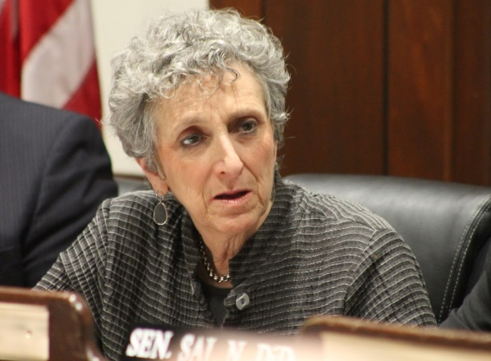

At the request of Dignity Alliance, the Joint Legislative Committee on Elder Affairs held an informational hearing on October 13, 2020 to gather input on lessons learned in long-term care during the COVID-19 pandemic and steps that should be taken to reduce the serious illness and death in nursing facilities and assisted living residences. Approximately two-thirds of all Massachusetts COVID deaths occurred among residents and care staff in long-term care. Dignity Alliance appreciates the leadership of the Legislature and will advocate for legislative and regulatory reform in the 2021-2022 session of the Legislature to implement the lessons learned which, in most cases, highlighted deficiencies that have long plagued long-term care facilities. Among the reforms would be single rooms, stronger infection prevention and control, adequate supplies for testing and personal protective equipment (PPE), and requirement for staff to receive influenza and, when available, COVID vaccinations. Dignity Alliance adopted a resolution dated November 3, 2020 calling upon all long-term care staff and others to improve vaccination rates to achieve the CDC recommended rate of at least 90%. (Goal #4. Strengthening Age-Friendly Emergency Procedures and Response)

**Worker Support**

Immediate and comprehensive enhancement of supports, including, but not limited to, sufficient and appropriate personal protective equipment (PPE), testing, paid sick time, and compensation for frontline workers confronting the current coronavirus outbreak as well as anticipating future needs.

Dignity Alliance supports the majority of the components of the Baker Administration’s “Nursing Facility Accountability and Supports Package 2.0” introduced on September 10, 2020 and provided testimony including additional suggestions for regulatory reform in a letter dated November 9, 2020 relative to Proposed Amendments to 105 CMR 150.000 Standards for Long-Term Care Facilities – LCTF Standards – Staffing and Rooms.

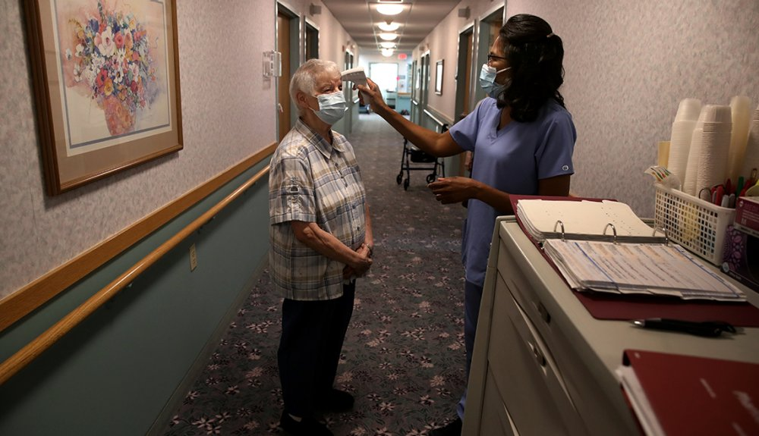

Dignity Alliance notes that the Baker Administration is now linking staff salaries and benefits to increases in reimbursement rates for skilled nursing facilities and requiring not less than 75% of state funds be utilized toward providing a living wage for nursing facilities staff with the intent of reducing the needs for working at multiple facilities which leads to potential disease transmission. Dignity Alliance also supports adequate testing and protective equipment and paid sick/family leave. (Goal #3. Protecting and Supporting Caregivers of Older Adults and People with Disabilities)

**Increase Housing Options**

Increase support for affordable and accessible housing, especially with service availability.  Many people remain in a facility long after they have recovered from an illness or injury because they cannot find suitable living accommodations.



Dignity Alliance advocated for the action by the Governor and Legislature in early December to increase funding for the Alternative Housing Voucher Program ($12.5 million including $1.9 million rollover funds) in line item #7004-9030 and including the requested additional $200,00 for line item 9110-1640 (elder behavioral health). Both funding items received the endorsement of Dignity Alliance, and members urged the Governor to retain this spending in the final FY ’21 State Budget. Housing assistance is vitally important to help more older adults and people with disabilities remain in the community instead of being forced to choose nursing home care, especially when they may not require such intensive health services and lose their dignity and independence in the process*. (Goal #2. Giving Meaning and Purpose to More Age-Friendly Communities)*

**Other Actions**

In addition to these important steps, Dignity Alliance also:

Provided Testimony to the Department of Public Health regarding the Department’s proposal for a limited relaxation of the Moratorium on new or re-purposed skilled nursing facilities – Essentially, Dignity Alliance does not believe there is a need to lift the moratorium. *(Goal # 1. Building a More Resilient and Higher Quality Long-Term Care System)*

Provided Testimony to the Department of Public Health regarding the Department’s effort to update Long-Term Care regulations 105 CMR 150.000. *(Goal #5. Increasing Oversight, Accountability, and Transparency of Long-Term Care Providers)*

Adopted a Resolution to the Massachusetts Congressional Delegation urging support a proposal offered by AARP and the Leapfrog Group for increasing infection reporting requirements by long-term care providers to the National Health Safety Network at CDC. *(Goal # 1. Building a More Resilient and Higher Quality Long-Term Care System)*

Adopted a Resolution to the Massachusetts Congressional Delegation to prevent a reduction of long-term care benefits for those born in 1960 that would occur if Social Security benefits are based on the 2020 economic statistics that were adversely impacted as a result of COVID-19’s economic impact. *(Goal #2.* *Giving Meaning and Purpose to More Age-Friendly Communities)*



Adopted a Resolution Supporting the Massachusetts Department of Public Health initiative to advocate for at least 90% compliance by staff, contractors, volunteers, and visitors to be vaccinated for Influenza and, when safe and available, for COVID-19. *(Goal #5 Promoting Accountability and Transparency in Long-Term Care)*

Strongly supported advocates and families in Western Massachusetts who opposed closure of Farren Care Center’s COVID-free specialized facility in rural Montague, and transferring approximately 100 frail residents with behavioral health diagnoses during the height of the COVID-19 Pandemic to Mt. St. Vincent Skilled Nursing Facility in Holyoke which was experiencing a high rate of infections. *(Goal #4. Strengthening Age-Friendly Emergency Procedures and Response)*

Dignity Alliance endorsed a number of pending bills and budget requests sponsored by member organizations and shared our positions with the Legislative Leadership and the Chairs of Senate and House Ways and Means Committees. (Bills and Budget Action supported several Dignity Alliance Goals, especially budget actions that support Goal #2 Giving Meaning and Purpose to More Age-Friendly Communities)



Developed a Legislative Advocate Guidebook to assist DAM members with citizen lobbying efforts in support of Dignity-endorsed legislation. *(Goal #5 Promoting Accountability and Transparency in Long-Term Care)*

Wrote to the Governor urging assistance to all residents of senior housing with COVID-19 testing, including independent living facilities. (Goal #2. Giving Meaning and Purpose to More Age-Friendly Communities)

Established and continues to publish ***The Tuesday Digest***, information compiled weekly by Dignity Alliance Massachusetts concerning long-term services, support, and care. We provide direct links to featured articles, listing and registration information on upcoming events by organizations that advocate or conduct research about older adults and people with disabilities. Each digest contains many more articles on key topics including Nursing Homes, Assisted Living, Home and Community, Housing, Behavioral Health, and Covid-1. Reaches over 500 key leaders and policy makers in Massachusetts. *(Supports the Mission of Dignity Alliance to educate others about issues concerning older adults and people with disabilities.)*

Adopted a Resolution on DAM’s Visitation and Isolation Prevention Recommendations urging comprehensive protocols which included three main principles: *(Goal # 1. Building a More Resilient and Higher Quality Long-Term Care System)*

* 1. Requested MA to establish that nursing home residents have a continued right to visitations and to apply those same visitation requirements to residents of rest homes and ALRs.
  2. Require facilities to allow visits by essential support persons.
  3. Set strong standards for end-of-life visits with residents to ensure quality time at the resident’s bedside.
  4. In Sept. 2020, DAM met with DPH to discuss its visitation policy.

To guide DAM’s advocacy, the Facility Workgroup selected 11 achievable short-term goals from a listing of 40+ goal recommendations:

1. Access to palliative care and palliative care clinicians.
2. Develop policy and protocols for visitations during future infectious periods
3. Establish minimum requirements for maintaining supplies of personal protective equipment for use by all facility personnel including housekeeping, laundry, maintenance, and dietary
4. Improve transitions of care between nursing homes and hospitals.
5. Maintain full-time infection preventionist in Nursing Homes per federal regulations (In Transparency & currency in reporting infection incidences & related deaths)
6. Mandate necessary vaccinations for all residents, staff and volunteers (i.e., Covid-19 when available, annual flu, pneumonia, shingles, etc.) **[See *10/7/20 DPH link below]**
7. Minimize multi-facility work by staff members
8. Minimize use of psychotropic medications
9. Publicly and prominently report key survey findings including infection rates, substantiated complaints, significant adverse events, average staffing rates (separately for certified nursing assistants, RNs, vs LPNs), and changes in ownership and management.
10. Strengthen vetting of new owners and management companies to ensure qualified new ownership and qualified in-state management
11. Transparency and currency in reporting infection incidences and related deaths

**\* 10/7/20 DPH Notice - Mandated Flu Vaccinations** [**https://www.mass.gov/doc/flu-vaccine-order-ltc-adh-dialysis/download**](https://www.mass.gov/doc/flu-vaccine-order-ltc-adh-dialysis/download)**: “…**all personnel are vaccinated against influenza virus by December 31, 2020, unless such administration is medically contraindicated, which means administration of influenza vaccine is likely to be detrimental to the individual’s health, or vaccination is against the individual’s religious beliefs. Personnel may not otherwise decline the vaccine…”

**Our Plans for the Future**

***“…transformative change to ensure the dignity of older adults, people with disabilities, and their caregivers.”***

**Goal # 1. Building a More Resilient and Higher Quality Long-Term Care System**

* We will advocate for resident-centered care with single occupancy rooms, full-time infection prevention, falls prevention, abuse prevention, strengthened family councils, small (max. 12 residents) facilities.
* We will advocate for maximum nurse and staff ratios.
* We will advocate for safe visitation policies in all long-term care, both congregate and home care.
* We will advocate for nursing homes to be the last option among choices for long-term care.
* We will advocate for improvements in care and treatment for older, frail inmates of correctional institutions.

**Goal #2. Giving Meaning and Purpose to More Age-Friendly Communities**

* We will advocate for adoption of a Community First 1815 Medicaid Waiver
* We will advocate for age-friendly, ADA compliant communities with affordable, accessible housing and public transportation.
* We will advocate for an end to ageism and ableism in every community in the Commonwealth.

**Goal #3. Protecting and Supporting Caregivers of Older Adults and People with Disabilities**

* We will advocate for living wage and enhanced benefits for caregivers.
* We will advocate for broadest possible education in geriatrics for all health care professionals and staff.
* We will advocate for behavioral health and wellness programs for long-term care staff.

**Goal #4. Strengthening Age-Friendly Emergency Procedures and Response**

* We will advocate for enhanced emergency plans, adequate supplies of testing, PPE, and vaccinations for residents and staff of skilled nursing facilities and home care aides.

**Goal #5. Increasing Oversight, Accountability, and Transparency of Long-Term Care Providers**

* We will advocate for improvements to the response to complaints and deficiencies in skilled nursing facilities.
* We will advocate for non-profit ownership of long-term care provider firms.

**Decision-Making with Dignity**

Dignity Alliance Massachusetts is comprised of advocacy organizations and concerned citizens led by a Coordinating Committee to guide the day-to-day activities of the coalition. Work-Groups focus on areas such as Legislation, Facilities and Regulations, Home and Community-based programs, Housing, Litigation, Behavioral Health, and Communications. Proposals for advocacy – whether legislation, regulations, resolutions or communication – generally arise from the work groups, but may also be suggested by individual dignity members or the Coordinating Committee. After review and discussion by the Coordinating Committee, matters are presented to the full membership of DAM for discussion and consensus approval. If consensus is achieved, the matter is circulated to the full membership for approval, disapproval, or abstention and members may also choose to add their names or the name of their organization as additional endorsements. The results of DAM’s support or opposition are then communicated to the appropriate official(s) or agency.

**Membership** (*) Designates Member of Coordinating Committee

Individuals

Doris Bardwell, RN

* Frank E. Baskin, LICSW

Joe Bellil

* Charles Carr, former Commissioner, Mass. Rehab. Commission

* Meg Coffin

Judi Fonsh, MSW, LICSW

* Lachlan Forrow, MD

* Shaya French

* Nomita Ganguly

* Arlene Germain

Wynn Gerhard, Esq.

Pamela Goodwin

Alex Green

Kathie Summers Grice, PhD

Jerry Halberstadt

* Bill Henning

Sandy Hovey

L. Scott Harshbarger, Former Attorney General

* Chris Hoeh

* Jeni Kaplan, Esq.

* Colin Killick

Janet Knott  
 James Lomastro, PhD

Linda Landry

* Paul J. Lanzikos, Former Secretary of Elder Affairs

Posie Mansfield

* Richard T. Moore, Former Senate President Pro Tempore *

Sandy Alissa Novack, MBA, MSW

Lisa Orgettas

* David Polakoff, MD

Vicky Pulos

* Clarence Richardson, Esq.

Yashira Ruiz

Marlene Sallo

Stephen Schwartz, Esq.

Sue Rorke

Kate Symmonds

Scott Trenti

* Alison Weingartner

**Membership**

Organizations

Alzheimer’s Association of Massachusetts & New Hampshire

Boston Center for Independent Living

Center for Living & Work

Center for Public Representation

COP Amputee Association

Disability Law Center

Disability Policy Consortium

Disability Resource Center

Easter Seals Massachusetts

Greater Boston Chapter, United Spinal Associates

Greater Boston Legal Services

Hospice and Palliative Care Federation of Massachusetts

Massachusetts Advocates for Nursing Home Reform

Massachusetts Law Reform Institute

MetroWest Center for Independent Living

Mystic Valley Elder Services

Mass NAELA (National Academy of Elder Law Attorneys)

SeniorCare, Inc.

Stavros Center for Independent Living

Stop Bullying Coalition

**Dignity Alliance Work Groups**

LEGISLATIVE – Chair: Richard T. Moore

FACILITIES AND REGULATIONS – Co-Chairs: Alison Weingartner and Arlene Germain

HOME AND COMMUNITY-BASED SERVICES – Chair: Meg Coffin

BEHAVIORAL HEALTH – Chair: Frank Baskin

HOUSING – Chair: Shaya French

COMMUNICATIONS – Chair: Chris Hoeh

LEGAL ISSUES – Co-Chairs: Jeni Kaplan and Clarence Richardson

COORDINATING COMMITTEE – Co-Chairs: Bill Henning and Paul Lanzikos